Fast API Documentation
Create folder in vs code as Fast Api create environment variable active the environment
After activate the environment please install library (pip install fastapi, uvicorn, pydantic)
Create main.py Run below code using (uvicorn main:app –reload)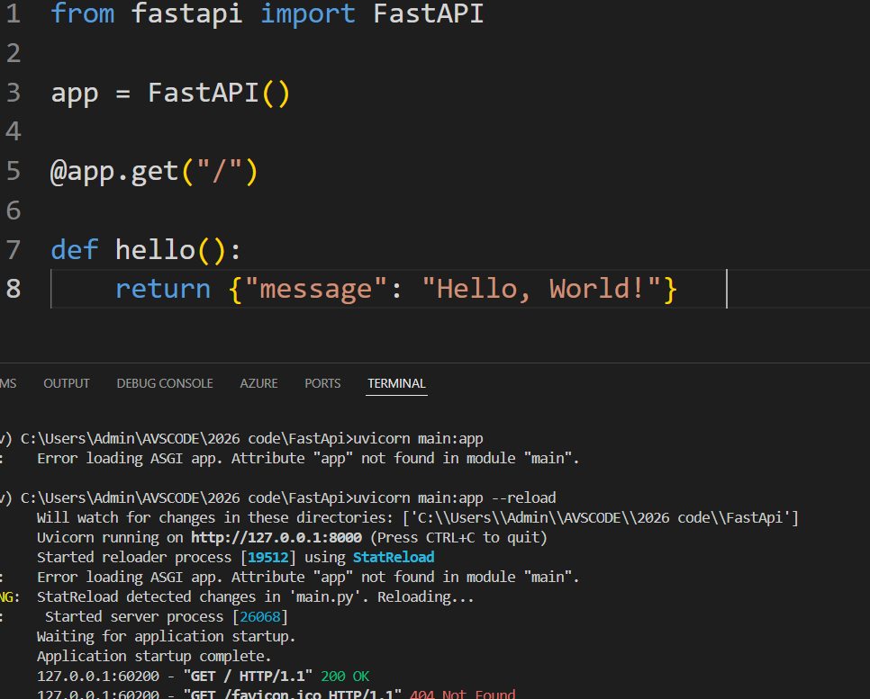
2nd code
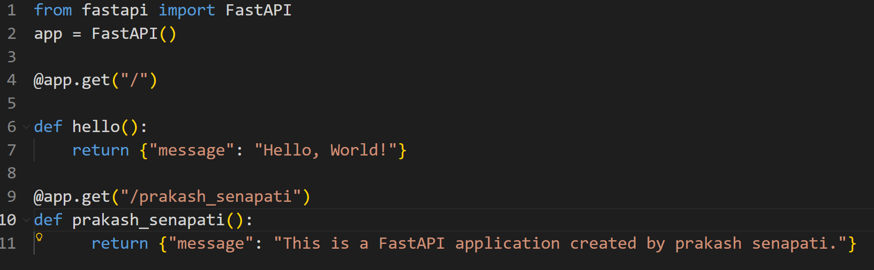
Frontend need to edit the url to
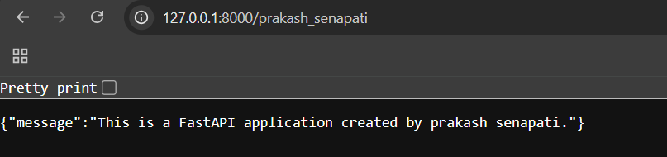

Finally we are create 2 end point hear
- http://127.0.0.1:8000
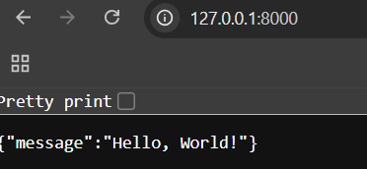
- http://127.0.0.1:8000/prakash_senapati

- If you enter below end point then it will generate auto generated documents
http://127.0.0.1:8000/docs
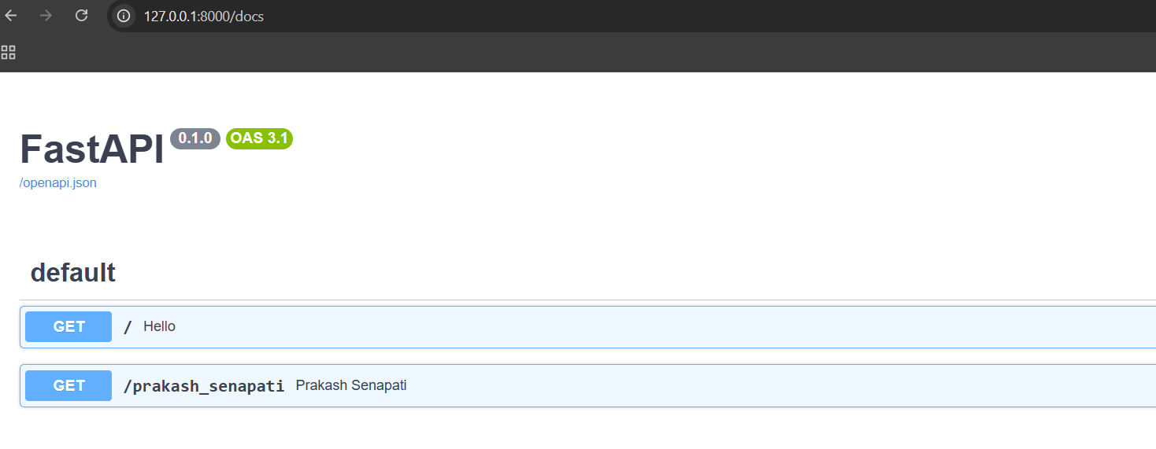
What is HTTP Methods?
Assume below is prescribed document about the patient. Sometime either doc or pt. both might loose the physical doc that’s why we are trying to building the app. which we will provide the app to doctor so that every pt. is one new records & developer is store all the pt’s records in one place.
Actually we supposed to store the data in DATABASE for the time being we are storing all the data in json file.
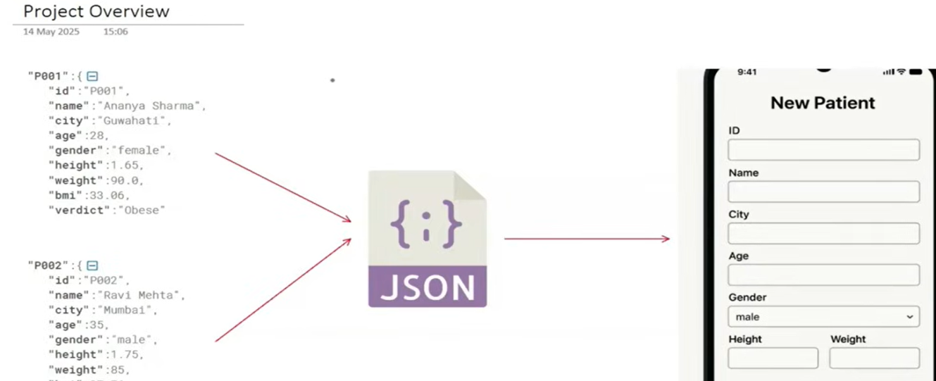
The good part is if sometime pt. weight will reduce then immediately app can update the pt.weight loss so that doctor can know the right & updated information about pt.
So finally what is our work we need to build one API hear. In this api we will create 4 to 5 end point.
1st end point – we will create pt record will add in json
2nd endpoint – to view all the pt. records
3rd endpoint – to view only 1 specific pt. profile
4th endpoint – to view some specific pt. profile
5th end point – for given pt. id we will delete the pt id
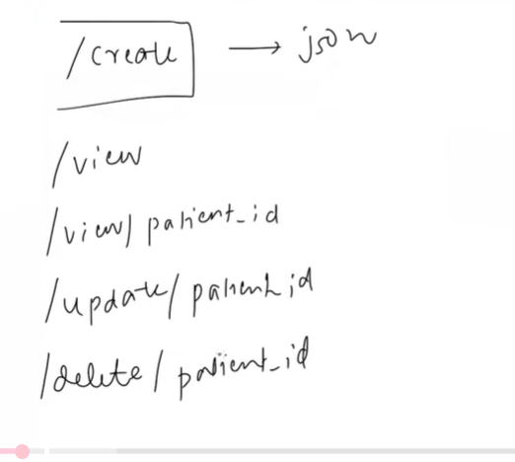
Main goal is we need to build api hear.
HTTP METHODS
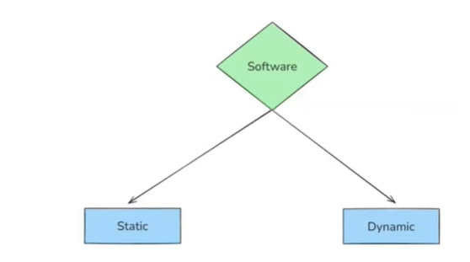
Static software is one way of communication eg – from mobile we watch calendar (we see the date and closed)
Dynamic software is excel user can interact with multiple lavel. Finally I can say we can perform
CRUD operation with excel( create, retrieve, update, delation)

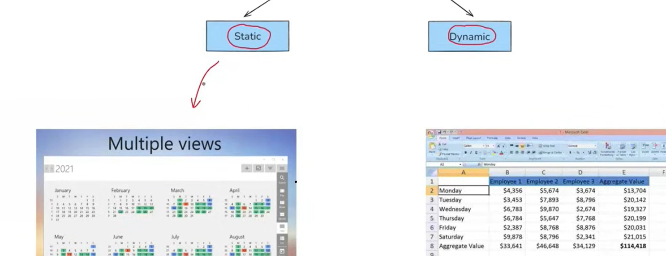

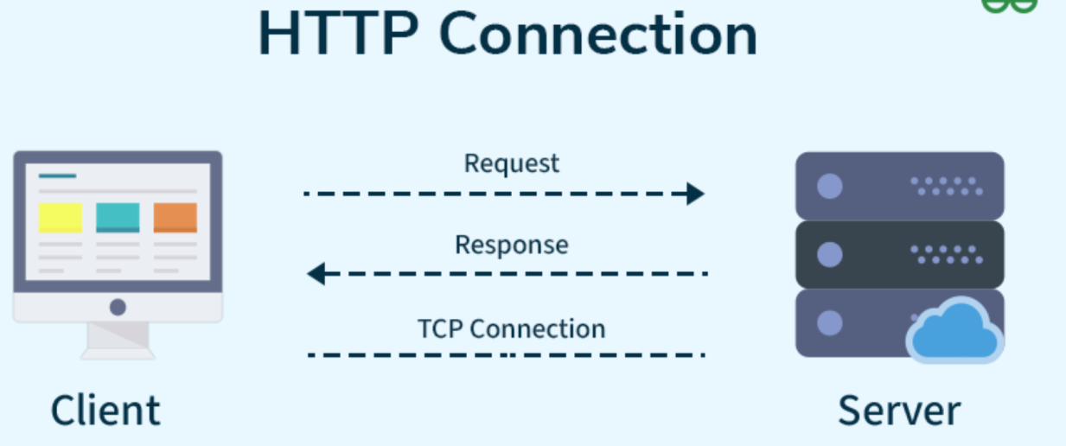
Please open google image to the learner for more explanation.

